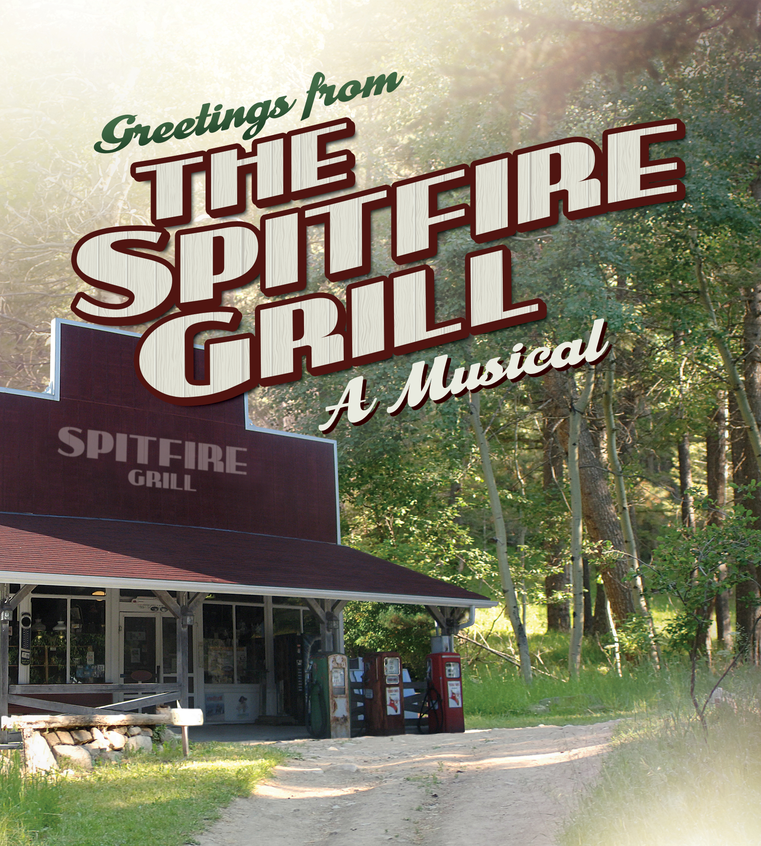
CONTACT: Nancy Richards – 917-873-6389 (cell)/nancy@northcoastrep.org
MEDIA PAGE: www.northcoastrep.org/press

FOR IMMEDIATE RELEASE, PLEASE:
NORTH COAST REP SERVES UP TASTY MUSICAL FEAST
WITH ‘THE SPITFIRE GRILL, A Musical’
Book and Music by JAMES VALCQ
Lyrics and Book by FRED ALLEY
Based on a Film by LEE DAVID ZLOTOFF
Performances Beginning Wednesday, May 31, 2017
Running Through Sunday, June 25, 2017
EXTENDED TO JULY 2, 2017
Directed by Jeffrey B. Moss

Solana Beach, Calif. North Coast Repertory Theatre opens its doors to THE SPITFIRE GRILL, A Musical, an honest, emotional musical about a young woman with an uncertain past. Filled with inspirational melodies and an engaging score, this heartwarming tale of fortitude and redemption offers an abundance of joy and goodwill. Come see why The New York Times dubbed it “a soul-satisfying new musical.”

Jeffrey B. Moss directs Aurora Florence*, Devlin, Meghan Andrews*, Kevin Bailey*, Kevin Earley*, Maggie Carney*, and Matt Thompson. The design team includes Marty Burnett (Scenic Design), Matthew Novotny (Lighting), Chad Lee Thymes (Sound), Elisa Benzoni (Costumes), and Andrea Gutierrez (Props). Cindy Rumley* is the Stage Manager. Alby Potts is the Musical Director.

*The actor or stage manager appears through the courtesy of Actors’ Equity Association, the union of professional actors and stage managers in the United States. For background information and photos, go to www.northcoastrep.org/press

THE SPITFIRE GRILL, A Musical previews begin Wednesday, May 31. Opening Night on Saturday, June 3, at 8pm. There will be a special talkback on Friday, June 9, with the cast and artistic director. It will play Wednesdays at 7pm, Thursdays through Saturdays at 8pm, Saturday and Sunday matinees at 2pm with Sundays at 7pm, through July 2nd. (See Schedule below.) North Coast Repertory Theatre is located at 987 Lomas Santa Fe Drive, Solana Beach, CA 92075. Tickets: Previews- $42, Week Nights - $49; Sat. Eve. & Sun. Mat. $53; Sat. Mat. & Sun. Night - $46. Seniors, Students, Military - $3 off admission. Call 858-481-1055 or visit www.northcoastrep.org to purchase tickets.

FACT SHEET

WHAT: NORTH COAST REPERTORY THEATRE presents
THE SPITFIRE GRILL, A Musical
Book and Music by James Valcq
Lyrics and Book by Fred Alley
Based on a Film by Lee David Zlotoff
Directed by Jeffrey B. Moss

CAST: Aurora Florence,* Devlin, Meghan Andrews,* Kevin Bailey,* Kevin Earley,* Maggie Carney,* Matt Thompson

WHERE: North Coast Repertory Theatre
987 Lomas Santa Fe Drive, Ste. D
Solana Beach, CA 92075

SCHEDULE Previews: May 31, 2017
Opens: June 3, at 8 pm
Closes: June 25, 2017 EXTENDED TO JULY 2
Wed. @ 7pm, Thurs-Sat @ 8PM; Sat & Sun @ 2PM, Sun @ 7pm
Talkback with cast & director: Friday, June 9, 2017

PRICES: Previews $42.00
Week Nights $49.00
Sat. Matinees & Sunday Nights $46.00
Sat. Nights & Sunday Matinees $53.00

DISCOUNTS: Seniors, Students, Military $3.00 off admission

BOX OFFICE (858) 481-1055 or www.northcoastrep.org

SUN | MON | TUE | WED | JUNE THU | FRI | SAT
 |  |  | MAY 31  Preview  8pm | 1  Preview  8pm | 2  Preview  8pm | 3  OPENING  8pm
4  2pm & 7pm | 5 | 6 | 7  7pm | 8  8pm | 9  8pm  Talkback | 10  2pm & 8pm
11  2pm & 7pm | 12 | 13 | 14  7pm | 15  8pm | 16  8pm | 17  2pm & 8pm
18  2pm | 19 | 20 | 21  7pm | 22  8pm | 23  8pm | 24  2pm & 8pm
25  2pm | 26 | 27 | 28  7pm | 29  2pm | 30  2pm | July1  2pm & 8pm
July 2
2pm

BIOS:

JAMES VALCQ (Book & Music) is a musical theatre composer, lyricist, and librettist, best known for his contributions to The Spitfire Grill, which won the Richard Rodgers Production Award presented by the American Academy of Arts and Letters and received Best Musical nominations from the Outer Critics Circle and Drama League, as well as two Drama Desk nominations. Also, Off-Broadway, Valcq wrote the book, music, and lyrics for Zombies from The Beyond, which opened to great critical acclaim in 1995. Both The Spitfire Grill and Zombies from The Beyond have become staples in regional theatres, particularly The Spitfire Grill, one of the most frequently performed recent musicals with more than 350 productions to date, not only in every major American city, but also in Canada, Germany, South Korea, Australia, and Japan as well. Other New York credits include Fallout Follies at the York Theatre, Songs I Never Sang For My Father at the Village Theatre, and The Last Leaf, collaboration with Tony-nominee Mary Bracken Phillips. He holds an MFA from NYU’s Musical Theatre Program and a BFA from the University of Wisconsin–Madison. In addition to musicals, Valcq has composed song cycles and choral pieces which have been performed in the U.S. and Europe.

FRED ALLEY (Lyrics & Book) was an American musical theatre lyricist and librettist who died unexpectedly just as his work gained national recognition. His collaboration on the musical The Spitfire Grill with composer James Valcq won the American Academy of Arts and Letters' prestigious Richard Rodgers Production Award for 2001. Premiered at the George Street Playhouse in New Jersey and produced Off-Broadway by Playwrights Horizons, it received Best Musical nominations from the Outer Critics Circle and Drama League, as well as two Drama Desk nominations. The cast album was released on Triangle Road Records. The Spitfire Grill has become one of the most frequently performed recent musicals with more than 300 productions to date, not only in every major American city but in Canada, Germany, South Korea, and Japan as well. In 2008 the show had its UK premiere at the Edinburgh Festival Fringe.

LEE DAVID ZLOTOFF (Wrote & Directed Film) is a producer, director and screenwriter best known as the creator of the TV series “MacGyver.” He started as a screenwriter writing for “Hill Street Blues” in 1981. He then became a producer of “Remington Steele” in 1982. Zlotoff also created “MacGyver,” which ran on ABC between 1985 and 1992 and was sold throughout the world. He then produced the TV series “The Man from Snowy River” (Australian title: "Banjo Paterson's The Man from Snowy River" — American title: "Snowy River: The McGregor Saga"). The series was loosely based on the Banjo Patterson poem “The Man from Snowy River” He also wrote and directed the 1996 film “The Spitfire Grill,” which won the Audience Award at the Sundance Film Festival and was nominated for the Grand Jury Prize. Zlotoff graduated Brooklyn Technical High School, which provided a general technical/pre-engineering education. Zlotoff then went on to St. John's College in Annapolis, Maryland. He also contributes to Make Magazine.

JEFFREY B. MOSS (Director) is the director of the critically acclaimed recent Off-Broadway production of Bock and Harnick’s Rothschild & Sons which will soon be seen in London. He often directs newly imagined productions of classic musicals such as Golden Boy and Rags (seen at The Coconut Grove Playhouse and Paper Mill Playhouse) and his work also includes the development of new plays and musicals such as Before the Dream by Charles Strouse and Leslie Lee. He has staged over 35 national and international tours, and in New York he directed the hit musicals Mayor and Little Me, and was the director of the New York and Kennedy Center productions of Some Enchanted Evening, now part of the Rodgers and Hammerstein Library. He directed the stage and television versions of Barry Manilow's musical, The Drunkard and his acclaimed international production of My Fair Lady just premiered in China.
AURORA FLORENCE* (Percy Talbott) is thrilled to be joining the cast and crew of Spitfire. A graduate of BYU’s musical theatre program, some of her favorite theatre roles include Eliza Doolittle (My Fair Lady, International Tour), Hermia (A Midsummer Night’s Dream, Secret Theatre NYC), Dorine, (Tartuffe, Midtown Players NYC), Penny (Hairspray), and Miss Dorothy (Thoroughly Modern Millie). Aurora can be seen on screen in A. Todd Smith’s “Mr. Bellpond,” Devin Graham’s “Rabbit Foot,” and Cassidy Hilton’s “Fix You.” Also a singer/songwriter, Aurora was a founding member of Imagine Dragons and has an album of original songs entitled “It’s Wonderful,” available on iTunes. Huge thanks to Jeff and the North Coast Rep family for this opportunity. Love to my husband, our little ones, and the Big Man Upstairs. @auroraflorence for updates.

DEVLIN (Hannah Ferguson) Recent appearances – The Geez and Me (Rag Lady Productions/10th Avenue Theatre); Sunday In The Park With George (ION Theatre); The Heir Apparent (Scripps Ranch Theatre); Eternally Bad (Moxie Theatre); Into The Woods (New Village Arts); Frankie and Johnny in the Clair De Lune (Vantage Theatre); Blood Relations and The Musical Comedy Murders of 1942 (North Coast Rep). Additional theatre appearances: San Diego Rep, Lamb’s Players and Diversionary Theatre. Devlin made her New York cabaret debut in 2007 and released her CD “Devlin Live in New York” at Barnes and Noble Lincoln Triangle. New York night club appearances - The Metropolitan Room, Don’t Tell Mama, Helen’s and Birdland. San Diego night club appearances - Martinis Above Fourth and Humphreys Backstage. Thrilled to be back at NCRT! Love to S & C.

MEGHAN ANDREWS* (Shelby Thorpe) Frost/Nixon (Broadway & National Tour - Donmar Warehouse), The Grapes of Wrath (Broadway - Steppenwolf). The Trip to Bountiful, (Off-Broadway - Signature Theatre, Goodman Theatre, Chi) Lucille Lortel Nomination. As a child actor, Meghan was the original Mary Lennox in the first Pre-Broadway Jujamcyn production of The Secret Garden. Other Theatre credits include Collected Stories (Rubicon Theatre, CA), Miracle on South Division Street (Colony Theatre, LA), The Empty Man (The Blank Theatre, LA), Educating Rita (North Coast Rep), Words By, Ira Gershwin...(North Coast Rep), Doubt (George Street Playhouse), Clocks and Whistles (Origin Theatre Company, NYC), All’s Well That Ends Well (Blessed Unrest, NYC), Dracula (Fulton Opera House), and others. Television: “Justified”, “Law & Order: C.I.,” “Flesh ‘n Blood” and others. Film: “The Big Swim,” “Drifting,” “The Adjustment Bureau,” and others. Meghan is a graduate of the SUNY Purchase Acting Conservatory, and a lifetime member of the Actors’ Studio. Thank you to my amazing voice coach Eddie Sayegh! ... and to my dear Hunna: I love you more each day… www.meghanandrews.com.

KEVIN BAILEY* (Caleb Thorpe) is thrilled to be back at NCRT where he has played Bingham in Fox on the Fairway and Sam in the film noir musical, Gunmetal Blues. Kevin just completed a workshop production of the play, God Looked Away, at the Pasadena Playhouse, which starred Al Pacino and Judith Light. Broadway: original company The Lion King (Scar, also LA Company); Annie Get Your Gun, with Bernadette Peters (Sitting Bull and u/s for Frank Butler). Off-Broadway: The Doctor’s Dilemma (Walpole), A Midsummer Night’s Dream (Demetrius). National Tours: The Foreigner (David Lee); The Fantasticks (El Gallo). Regional: two seasons as the Grinch in The Grinch… at The Old Globe, Kiss Me Kate (Fred/Petruchio), Miss Saigon (Engineer – Ovation Nomination), title role Jekyll & Hyde. For ICT in Long Beach, the Devil in the LA premiere of Abigail 1702 and last season’s revival of Closer than Ever. Always for James, Nora and Will.

KEVIN EARLEY * (Sheriff Joe Sutter) Just finished playing Pilate in Jesus Christ Superstar over the Easter Holiday at North Carolina Theater. His Broadway and National Tour credits include Les Misérables, Thoroughly Modern Millie and A Tale of Two Cities. An appetite for new works was fulfilled last year with three new musicals; Chasing Rainbows at Goodspeed, Josephine at Asolo and Empire, the Musical at La Mirada Theater. Awards include NY Drama Desk Nomination for the title role in Death Takes a Holiday, L.A. Drama Critic’s Circle Award for 1776, Joseph Jefferson Award for Assassins and four Ovation Nominations for leading roles in Can-Can, Sleeping Beauty Wakes, It Came From Beyond, and Side Show. On July 9th, Kevin will be performing with the California Philharmonic in the beautiful Disney Hall in downtown Los Angeles. His recording of “Earley Standards” is available on iTunes and more can be found at kevinearley.com

MAGGIE CARNEY* (Effy Krayneck) is delighted to make her North Coast debut with The Spitfire Grill. Elsewhere: La Jolla Playhouse: Midsummer Night’s Dream, Peter and the Starcatchers. Old Globe: Pygmalion. Cygnet Theatre: Sons of the Prophet, The Importance of Being Earnest, Travesties, A Christmas Carol. Intrepid: The Quality of Life. Diversionary: Divine Sister. Mo’olelo: Yellow Face, Milvotchkee, Wisconsin. Seattle Rep: Bill Irwin’s Largely/NY, The Tempest. Writers’ Theatre: A Phoenix Too Frequent, Spite for Spite. Famous Door: Ghetto. BoarsHead: Bad Dates. Touchstone Theatre: Bedroom Farce, Into the Woods. Bailiwick: Smash. She has also appeared with Northlight Theatre, Roadworks Productions, Noble Fool Theatricals, Chicago Shakespeare Theater, The Poetry Foundation, The Second City, Creede Repertory Theatre, Peninsula Players in Door County, Wisconsin and the Wisconsin Shakespeare Festival. Maggie can be seen in the movie musical “Lucky Stiff” on Amazon and iTunes.

MATT THOMPSON (Visitor) Select acting credits: The Car Plays, The Grift (La Jolla Playhouse) Spring Awakening (Cygnet Theatre); Dead Man’s Cell Phone (Moxie Theatre); Now or Later (Diversionary Theatre); Much Ado About Nothing (Intrepid Theatre); Henry V (New Fortune Theatre) The Odd Couple, THIS, Don’t Dress for Dinner, Over the Tavern, Dracula, Leading Ladies, A Thousand Clowns, Julius Caesar, The Comedy of Errors (North Coast Rep), Terra Nova (Compass Theatre); Cold Comfort Farm, West Side Story (Lamb’s Players), Shear Madness (The Theatre in Old Town), The Tempest (Kingsmen Shakespeare), Rapunzel (Falcon Theatre), Moonlight & Magnolias (Sierra Repertory Theatre). TV credits: “C.S.I,” “Veronica Mars,” “Fashion House,” “Cover Me,” “Dharma and Greg,” “Watch Over Me,” “18 Wheels of Justice,” “The Invisible Man,” and “Baywatch.” Also a playwright, Mr. Thompson’s plays have been published through Dramatic, Heuer, and Eldridge Publishing. His non-fiction book entitled “Solana Beach” can be found through Arcadia Publishing.

CINDY RUMLEY* (Stage Manager) Credits include: Laughter on the 23rd Floor, Ain’t Misbehavin’, Way Downriver; William Faulkner’s ‘Old Man’, Chapatti, Side By Side By Sondheim, Freud’s Last Session, Mandate Memories, Dames at Sea, Two By Pinter, and Visiting Mr. Green with North Coast Rep. Snapshots with The Pico Playhouse, Bye Bye Birdie with San Diego Musical Theater, and Conference of the Birds with The Moscow Art Theater. Cindy holds an M.F.A in stage management from UC Irvine and is a member of Actor’s Equity Association. In her free time, Cindy enjoys being married to the amazing Mr. Aaron Rumley.

ALBY POTTS (Musical Director/Keyboard) is delighted to return to North Coast Rep, having previously music directed Side by Side by Sondheim here. Los Angeles credits include Singin’ In The Rain (Ovation Award winner) and Miss Saigon (Ovation nomination); Chicago musical directing credits include Into The Woods and Brigadoon (Jeff Award nominations). Alby has played keyboards for national tours of Wicked, Beautiful, Sound of Music, Book Of Mormon, Wizard of Oz, Evita, Addams Family, West Side Story, White Christmas, Spamalot, and many LA area productions. Also a composer, Alby’s CD, “Dreaming For Real,” charted number one nationally on independent radio stations. Alby’s song, “Joy, Hope, and Peace,” appeared on George Winston’s Grammy nominated album, “Montana-A Love Story.” Film score credits include “Season of Change,” “Frozen in Fear,” “Dance,” “Search For A Heavyweight Contender,” and others. Alby graduated from the Boston Conservatory of Music and Northwestern University.

MUSICIANS:
ALBY POTTS – KEYBOARD – See Musical Director Bio

NIKKO NOBLEZA (Guitar/ Mandolin) has been playing guitar for 13 years and plays a variety of styles. He recently received his B.M. in Jazz Studies from San Diego State University. Currently, Nikko is in a rock/Top 40 cover band where he is the lead guitarist, manager, and mascot. He is also the in-house composer for two film production groups, Almost Good Films and Jabronie Pictures. Nikko runs a Youtube channel where he makes videos of music, video gameplay, and “Nikko’s Kitchen,” a mini-series of instructional cooking videos.

CATHY GRAY (Violin) born in Illinois, Catherine Gray grew up in a musical family. An accomplished freelance musician, she has performed at many freelance venues around San Diego County for the past 32 years including Starlight Opera, San Diego Chamber Orchestra, and the Welk Resorts Theatre. Catherine has performed with Natalie Cole and Andrea Boccelli with the San Diego Symphony among others. She also holds two California teaching credentials and has spent thousands of hours instructing music students of all ages and abilities in San Diego County Schools and in her private studio. She currently performs regularly with The Vintage Strings. Catherine is currently pursuing a master's degree in humanities.

DESIGN TEAM:
MARTY BURNETT (Resident Scenic Designer) Marty is in his 25th season as Resident Designer/Technical Director at North Coast Rep. He has designed the last 175 shows. Other venues include Laguna Playhouse, Portland Stage Company, Drury Lane (Chicago), Claridge Hotel (Atlantic City), Union Plaza, Sahara Hotel, Hacienda in Las Vegas, Coronado Playhouse, Scripps Ranch Theater, Harrah’s Lake Tahoe. Marty is a proud alumni of Creighton University in Omaha, Nebraska.
MATTHEW NOVOTNY (Light Design) is pleased to be designing another show for North Coast Rep, where he has designed close to 40 shows over the past seven years. Matthew is currently the Lighting Designer in Residence for San Diego Musical Theatre as well as North Coast Rep, and his work can be seen at a wide variety of theatres across San Diego. Matthew holds a BA in Technical Theatre from San Diego State, and a master’s degree in Lighting Design from Boston University. Matthew is married to his beautiful wife Amanda, with 3 gorgeous children: Ragan, Harper and Heston.
CHAD LEE THYMES (Sound Designer) The Buddy Holly Story (Intrepid Theatre Company), Into The Woods (Salomon Theatre), On The 20th Century (Cygnet Theatre, Playwrights Project 2017), Oklahoma! (New Village Arts), Romulus Kilgore's Mobile Happiness Bazaar (La Jolla Playhouse WOW Festival), Campo Maldito (New York Fringe Festival), The Mango Farmer of Vermont (UCSD New Play Festival). www.soundthyme.com

ELISA BENZONI (Costume Design) is thrilled to be working with North Coast Rep again. Previous work with North Coast Repertory Theatre includes: Travels with my Aunt, The Illusion, Marjorie Prime, Laughter on the 23rd Floor, The Cocktail Hour, Hedda Gabler, Sherlock Holmes and the Adventure of the Great Nome Gold Rush, Chapatti, The Fox on the Fairway, for which she was nominated for a Craig Noel Award; Other select credits: Sex with Strangers (Geffen Playhouse), Constellations (Old Globe) Pericles, Prince of Tyre, Reckless, Much Ado About Nothing, Measure for Measure (Old Globe/USD); The Who and The What, Our Town, Tall Girls, Brahaman/I, Sam Bendrix at the Bon Soir (La Jolla Playhouse); Emilie, Sylvia, Much Ado About Nothing (New Village Arts), Snakeskin, Lifeblood Harmony, Chagall, A Man Found Wanting (Malashock Dance); The Storm, The Threepenny Opera, A Man, His Wife, and His Hat (UCSD). Assistant costume credits: Dialogues des Carmelites (Teatro Petruzzelli, Bari), Paradise Found (Menier Chocolate Factory, London), Milk Like Sugar (La Jolla Playhouse), As You Like It, A Midsummer Night’s Dream (The Old Globe). Elisa holds a costume design MFA from UCSD. www.elisabenzoni.com.
ANDREA GUTIERREZ (Prop Design) has been working at North Coast Rep since 2012, beginning as the Stage Manager and Prop Master for our theatre school. She worked as backstage crew for the 32nd and the beginning of the 33rd Season, before taking over as Supervising House Manager and Volunteer Coordinator. Her previous prop credits include: Travels with my Aunt, The Illusion, Marjorie Prime, Laughter on the 23rd Floor, The Cocktail Hour, Ain’t Misbehavin’, Hedda Gabler, Way Downriver; William Faulkner’s ‘Old Man’, Now You See It, Sherlock Holmes and the Adventure of the Great Nome Gold Rush, Chapatti, and The Fox on the Fairway, as well as two seasons as Properties Assistant at Starlight Theatre. She received her B.A. in Theatrical Design and Production from UCLA’s School of Theatre, Film & Television, and a M.A. from Johns Hopkins University.
PETER HERMAN (Hair & Wig Design) has previously designed wigs for over 30 North Coast Rep productions including: The Illusion, Marjorie Prime, Laughter on the 23rd Floor, The Cocktail Hour, Way Downriver; William Faulkner’s ‘Old Man’, Now You See It, Sherlock Holmes and the Adventure of the Great Nome Gold Rush, Fallen Angels, Romance Romance, Faded Glory, Mandate Memories, The School For Lies, Honky Tonk Angels, Travesties, I Love You Because, Little Women, My Name is Asher Lev and Five Course Love. He has also designed costumes for past North Coast Rep productions: 25th Annual Putnam County Spelling Bee, The Big Bang, Madagascar, and Jacques Brel is Alive and Well and Living in Paris. Peter teaches wig and makeup design at San Diego State University. He is glad to be part of the creative team on this show.
BACKGROUND:
Season 35 concludes with a second San Diego premiere, a gut-busting, uproarious backstage farce, At This Evening’s Performance (July 12-Aug. 6, 2017).

Summer Show will be Tom Foolery (August 17- 27, 2017). Written by Cameron Mackintosh and Robin Ray / Music and lyrics by Tom Lehrer
A revue of the witty, wicked and thoroughly twisted world of famed satirical songwriter Tom Lehrer. Four actors, stools, a piano and a healthy dose of attitude are all that you need to enjoy this delightful revue. Audience will be beside themselves with the clever lyrics and hummable tunes. Rediscover the man and the songs that have delighted and skewered the world for over forty years in Tomfoolery!

About the North Coast Repertory Theatre:
North Coast Repertory Theatre, under the artistic leadership of David Ellenstein since 2003, is a professional Equity theatre founded in 1982 by Olive and Tom Blakistone. Currently celebrating its 35th season, North Coast Rep has received critical acclaim from media and audiences alike, and has evolved into one of the area’s leading performing arts organizations. North Coast Rep prides itself on employing the majority of its actors from Actors’ Equity Association for its high quality, award-winning productions, and staging works by established and emerging playwrights. Throughout its history, North Coast Rep has created a platform where artist and audience thrive through the intimacy of live theatre, recognizing the power of theatre to challenge complacency, revitalize the imagination, nurture the unexpected, and embrace the variety and diversity in our lives.

#####

